

Machine Learning-Music Recommendation

Progress Report

| Roll No. | Name of the Student | Name of the Program |
| --- | --- | --- |
| AU1940142 | Shail | ML |
| AU1940267 | Sahil | ML |
| AU1940034 | Varun | ML |
| AU1940109 | Jap | ML |

**Features created**

We tried generating features based on the chords of the song and tried to relate it with the already existing feature named liveness. The chords of the song play an important role in describing how the feel of the song turns out to be. We will be trying to generate a feature named chords which may be helpful in predicting the mood of the song and give us a better idea about what the user likes to listen to.

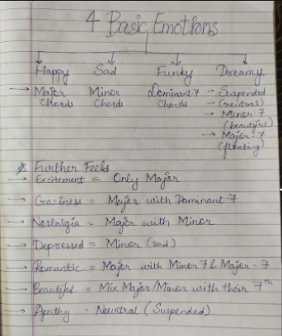

**Future work**

Next we will be looking at visualization of the relations between the variables in order to understand how much the variables are related to each other.